Year 2 Topic Homework: Towers, Tunnels and Turrets
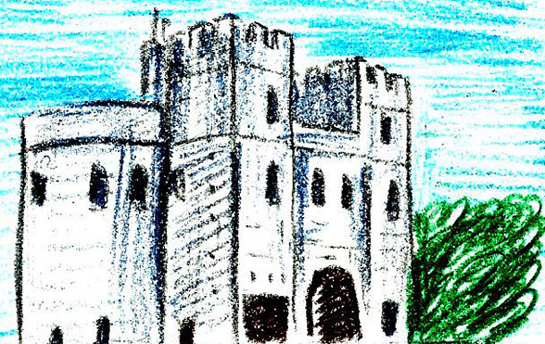

As well as the weekly literacy / numeracy homework task and reading every night, it would be fantastic if your child could complete 3 of the following tasks suggested in the list across this half term…

*Find out about famous engineers such as Isambard Kingdom Brunel. Use can use the internet or non fiction books. Have any famous engineers come from our local area?

*Play a tumbling tower game with members of your family. What are the best ways of keeping the tower upright? You might want to take action shots or videos of the towers falling?

*Make a detailed diagram of a castle, labelling interesting features which might be found inside or out.

*Make your own information book about castles, bridges or tunnels. What fascinating facts can you find out to amaze you’re family, friends and teacher?

*Find, on a world map, all the famous landmarks you would like to visit. Which continents are they in? How would you get there? Could you make a digital display to show your choices and reasons (e.g. PowerPoint presentation)?

