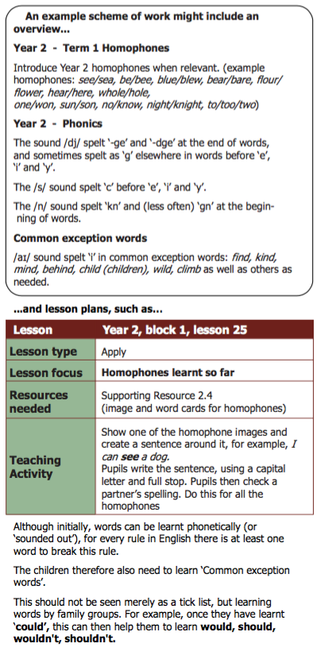

**Weaverham Forest Primary School**

**Helping Your Child with Spelling**

At Weaverham Forest Primary School, FS and KS1 implement the ‘Letters & Sounds’ phonics programme.

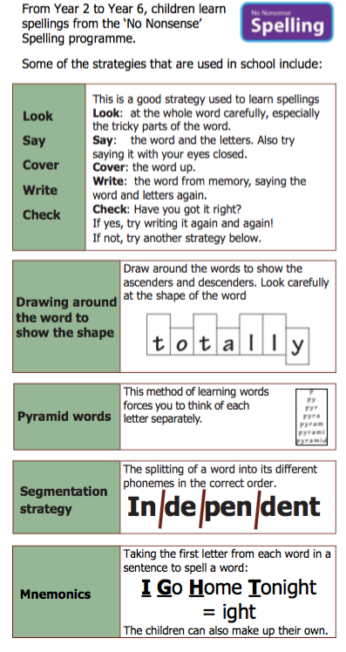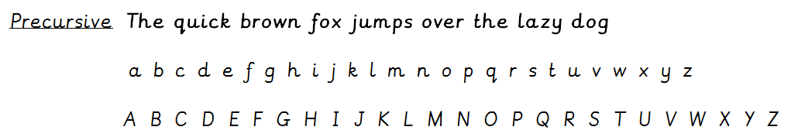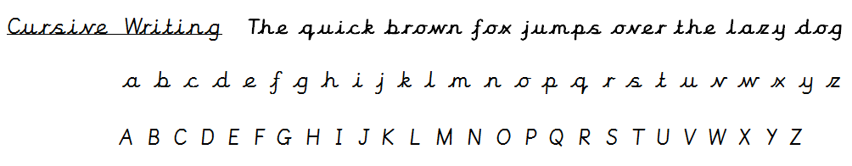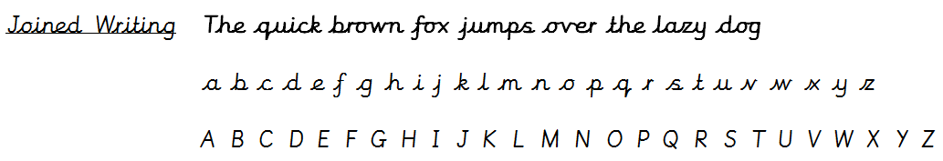

**Handwriting**

There is also strong research to show that practising spellings with handwriting can have a big impact.

The handwriting style we use at Weaverham Forest is introduced in phased stages through different year groups:

You will find more help with spelling on our website in Curriculum & Assessment.

**As with all learning, the emphasis should be on having fun.**

**Games are often a good way to do this. You could try:**

Eye Spy

Writing the word in rainbow colours

Spelling races with a family member Wordsearches

Matching pairs

Karaoke Spellings